The LARS Fox Hunt of Saturday 17 September 2005

Thursday evening Stanley and I decided to meet at Hardee's for breakfast Saturday morning. Friday, I was charging all the battery packs. The 7.2 volts at 4500 mA laptop battery was prepared. All of it was stuffed into one smaller box and put in the car.

Saturday morning was pleasant and a little foggy, but promised to get better. Stanley, KD4ERF, and I met for breakfast at Hardee’s. After breakfast we headed out behind Wal-Mart. The FOX radio was set to 300 mW with a wire dipole on a short piece of coax attached. After walking around checking out the possible fox dens, we found a nice depression on the edge of the hill facing Wally World. The sleeping FOX was gently laid down and the wire dipole was threaded in the grass (horizontally polarized) a few inches away from the chain link fence.

This FOX consisted of the Icom IC-2AT, laptop battery, wire dipole and Fox controller. It woke up and began barking at 10:00 AM and was then covered with a dark oily rag from the barn. Additionally, some dried grass was sprinkled over the rag and surrounding weeds. It really was hard to see!

GPS said: 37 degrees and 06.872 seconds N
84 degrees and 05.425 seconds W
1242 feet amsl

The following was transcribed from the traffic on 146.610.

Timeline:
10:00 FOX was turned on.
10:01 Jim, N4ICU, told Peter, KJ4ND, the FOX was ON.
10:02 Peter asked if anyone else could hear the FOX.
10:08 Peter announced he was mobile
10:11 Peter said it's over by ....... Neither Stanley or Jim could figure out what he said.
10:13 Stanley and Jim drove over to the Tractor Supply and waited for the hunter.
10:15 Peter arrived in the parking lot.
10:18 Peter says it's loud all over with the handheld and beam. Note: the hunters have been complaining that they can't hear the FOX and now Peter it's too strong!
10:20 Peter has the 2 element beams, now he's looking for a NULL.
10:26 Jim to Peter, Did you check the polarization? Peter, Uh, no I didn't.
10:37 Peter is back at the barn on Meyers-Baker Road, with an attenuator, now.
10:38 Peter is now looking around the house, then starts toward fence.
10:40 Peter is finding a full scale signal with no antenna, all along the fence.
10:45 Peter taking readings with the 2 element beams.
10:47 Took picture of Peter looking too far away from FOX.
10:48 Peter said the fence might be affecting the signal. Did I mention it's chain-link?
10:50 Peter is close, he stepped on it to look over the fence!
10:51 Peter is looking at the fence, tree roots, clumps of grass and keeps walking!
10:58 Peter is so happy, he found the FOX, after stepping on it again and feeling it move under his shoe.
10:59 Jim went to retrieve FOX, and it took me 30 seconds to find it!!!
11:00 FOX was uncovered, turned off and brought back.

This hunt reinforces the idea that long chain link fences retransmit a signal and fool a hunter into thinking it’s coming from another direction. Again, if the plastic radio case is not coated with shielding material then when in the near field of a transmitter the signal goes right through the case bypassing antennas and attenuators. In addition, by camouflaging the transmitter, the hunter loses the visual cues to find the FOX. All of these factors make finding the FOX much less likely and making it much more likely to frustrate the hunters.

73 & GOD Bless
Jim, Fox, FOX, standing under tree, N4ICU, Invisible Fox ………

Pictures taken
by Jim Russell N4ICU, a.k.a. “Sneaky Fox”

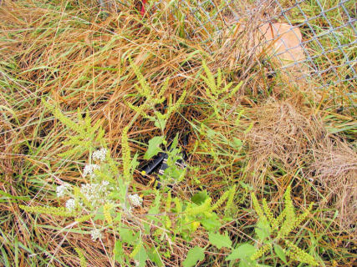

- FOX asleep in lair, in depression in ground,
uncovered.
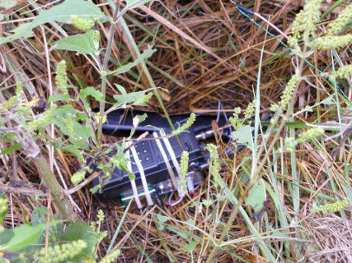

2. Close-up of sleeping FOX, uncovered.

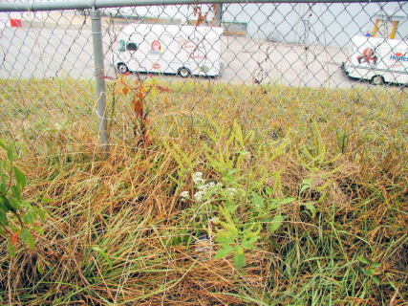

- Close-up #1 & #2, facing same as hunter’s
approach, showing back of Wally World.



4. Same as #3, but closer to the FOX.

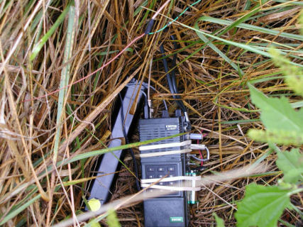

5. Clear view of sleeping FOX just before he
awakens.



6. FOX is covered with oily cloth and sprinkled
with dry grasses. FOX is AWAKE and TX’ing.

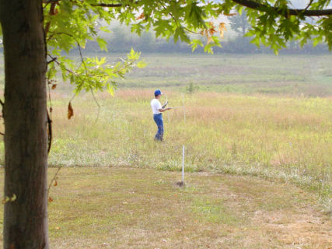

7. Peter KJ4ND using 2-element beam and is
pointing towards FOX.
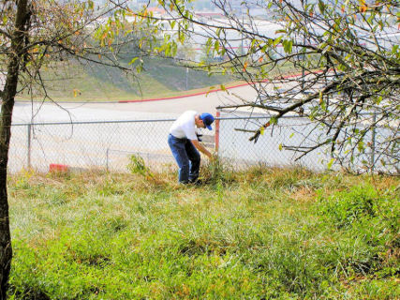

8. Peter grinning and pointing to the squashed
FOX that he found with his foot!

